Math 7 | APRIL 2020
{ Mrs. Jones: 443-390-6673 }

A virtual hello to you!

I hope you are well and would love to hear from you whether you are doing well or struggling during this strange time. It has been an odd transition for me and many of my family and friends, but I am thankful to be able to rely on a supportive community. I hope that we at Crossroads can be part of your supportive community.

Community Video Calls
In the spirit of that community, I would like to offer a weekly video call time for students to connect with each other and provide a sense of our usual classroom time together. This is completely optional. If students would like to participate, they can go to the website link on their phone or on a computer. You can then choose to show your video or not. Students can also choose to participate via phone audio only, which does not require internet access.

When: Every Tuesday from 11:20-11:40am (immediately before my available class time)
Video and audio: https://qrgo.page.link/5zSxx
Audio only, no internet required: call 571-392-7650 and enter PIN: 149 361 2084

Class Time Availability
If students would like more 1:1 or small group support from me, I will have a daily class time Monday-Friday, except on Wednesdays. During class time I will be immediately available to assist students in their virtual learning. If contacted outside this time, I will do my best to respond to you as quickly as I am able. Students can call, text, or video with me during this time.

When: 11:40am-12:40pm Monday-Friday, except Wednesdays ---- 443-390-6673

Work Expectations
I have provided approximately 40minutes of math each day as a combination of our usual weekly warm up & KhanAcademy (which I have made into an identical paper format as well). The work is very similar to what we would be doing in class if we were still at school as we usually spend this month reviewing all of our skills. While the warm up reviews a constant mix of skills to keep them all fresh, the KhanAcademy work is themed each week to focus on one unit and “due” Fridays at 10pm. Towards the end of the month you will see new work with our Geometry unit – please utilize the videos on KhanAcademy and YouTube and reach out if you have any questions. If students find the rigor to be too challenging or not challenging enough, please reach out to me for a modified curriculum.
7º de Matemáticas | Abril 2020
{ Sra. Jones: 443-390-6673 }
¡Reciban un saludo virtual!

Primeramente, espero que estén bien. Me encantaría saber de ustedes – si la están pasando bien, o si hay algo en el que podría serles de utilidad. Lo que en estos momentos estamos viviendo es complicado para todos: para mí, mi familia y amigos, por ejemplo. Sin embargo, estoy sumamente agradecida por que tengo a seres queridos que me dan amor y que me apoyan. Todos en Crossroads esperamos ser de ustedes una comunidad similar: una entidad en la que pueden confiar y encontrar amor y apoyo.

Videos a la Comunidad
Par que seamos verdaderamente una comunidad, me gustaría conectar con cada uno de mis alumnos por medio una llamada de video cada semana. Esto es completamente opcional: aquellos interesados podrían hacerlo ingresando al sitio web que aparece abajo. Hay dos opciones: hablar conmigo por video, o hablar conmigo simplemente vía audio, sin incluir imágenes o video. Aquellos que opten hablar conmigo solamente vía audio no necesitan tener acceso al internet. Comparto los detalles:
¿Cuándo? Cada martes, de las 11:20 a la 11:40 a.m. (es decir, inmediatamente antes de mi clase virtual).
Video y Audio: https://qrgo.page.link/5zSxx
Video (no se necesita el internet): teléfono: 571-392-7650 / PIN: 149 361 2084.

Disponibilidad Adicional
Para serles de más utilidad o para trabajar de forma grupal, hago de su conocimiento de que tendré clases virtuales a diario: de las 11:40 a.m. a las 12:40 p.m. (a excepción de los miércoles). Durante estas llamadas, podría contestar dudas de forma instantánea en esta nueva forma de aprender que estamos todos experimentando por primera vez. Aquellos interesados deben marcarme, durante el horario que previamente expliqué, al 443-390-6673.

Expectativas
El trabajo académico que le estoy dando a mis alumnos equivale a 40 minutos del día. En este tiempo, ya está incluido otras cosas que a diario hacemos en clase: las actividades de “warm up” y “KhanAcademy”. Todo es idéntico a lo que a diario hacemos en clase, sólo que ahora está impreso. Es decir, las actividades de “warm up” sirven repasar conceptos aprendidos en clase y “KhanAcademy” sirve para aprender algo nuevo cada semana (el concepto cambia cada semana). El trabajo de “KhanAcademy” se debe entregar cada viernes a las 10 p.m. Ojo: al final del mes, notarán nuevos conceptos de Geometría – utilicen los videos de “KhanAcademy” y “YouTube”, además, podrían comunicarse conmigo si lo ven necesario. Adicionalmente, aquellos que encuentren estas actividades demasiadamente difícil de hacer, podrían comunicarse conmigo para recibir un currículo diferente.

Khan Academy Daily Assignments
Please Text or call with questions!

443-390-6673
ASSIGNMENTS FROM TEACHER
- Once logged into KhanAcademy, look on the left side of the screen to select “Assignments”.
- Once there, review “Active” assignments and complete by assigned deadline.
- Additionally, confirm you have finished any “Past” assignments you might have missed.
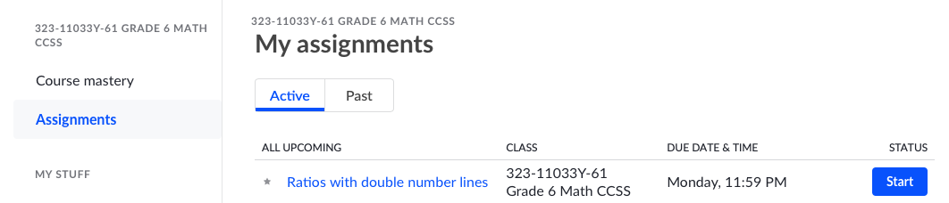

Khan Academy GROWTH Competition
- Prizes will be awarded to students who make the most percentage growth on their grade level course goal.
- There will be an additional big prize to anyone who reaches 100% course mastery by the assigned date!
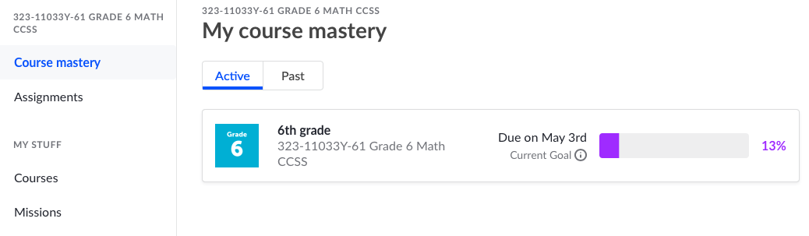
Increase this percentage!
Click here to get started on making overall course progress! Clicking the course title will bring you to the page shown below.
See the next page for details of how to log in and get started!
Clever.com Portal
Single sign on. Sign into this website and it automatically will sign you in to others.
Navigate to: CLEVER.COM
THEN CLICK HERE

LOGIN PROCESS

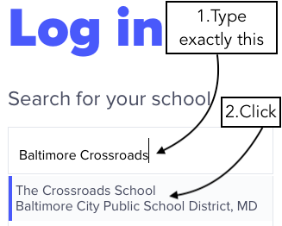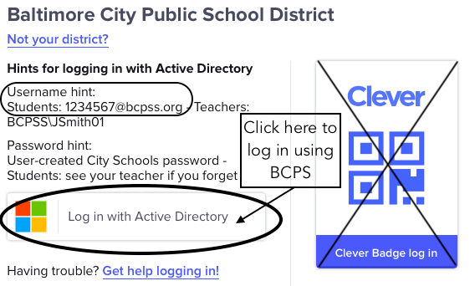
____________________________________________________________________________________________________________________________________________________________
Use your BCPS Login Information to sign in.

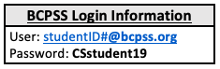

VIEW RESOURCES
If you click on these resources within Clever – it will take you directly there and login you in automatically! Click the heart them to add them to your favorites!

Math/Grammar Typing Language Coding Google Classroom GRADES

MATH 7 | APRIL | 2020
Sunday | Monday | Tuesday | Wednesday | Thursday |  | Friday |  | Saturday
Daily Schedule: | 30 | 31 | 1 | 2 |  | 3 |  | 4
☐ 15-20 min: Warm Up  ☐ 20-25min: Assigned KhanAcademy Tasks  (“Active” Assignments) | Hello!  Sending you all a virtual hug and hope you are well! Looking forward to connecting! |  | ☐ Text Mrs. Jones a picture of something that brings you joy!  I’ll text one back!  443-390-6673 |  |  | ☐ Finish March packet  ☐ Finish Khan Academy “Past” tasks assigned due by March 29th
5 | 6 | 7 | 8 | 9 |  | 10 |  | 11
Week1:  Fractions, decimals, and percentages + Negative numbers: multiply and divide | ☐ Warm Up #21 – Mon  ☐ Write decimals as fractions  ☐ Rewriting decimals as fractions challenge  ☐ Converting fractions to decimals  ☐ Order rational numbers | ☐ Warm Up #21 – Tues  ☐ Adding & subtracting rational numbers  ☐ Equivalent expressions with percent problems  ☐ Percent problems  ☐ Tax and tip word problems | ☐ Warm Up #21 – Wed  ☐ Discount, markup, and commission word problems  ☐ Rational number word problems  ☐ Signs of expressions  ☐ Multiplying negative numbers  ☐ Dividing negative numbers | ☐ Warm Up #21 – Thurs  ☐ One-step equations with negatives (multiply & divide)  ☐ Multiplying & dividing negative numbers word problems  ☐ Negative signs in fractions  ☐ Negative signs in fractions (with variables) |  | ☐ Spend 15-20 min on Khan mastery challenge  ☐ Multiplying positive and negative fractions ☐ Dividing positive and negative fractions  ☐ Dividing mixed numbers with negatives  ☐ Equivalent expressions with negative numbers |  | Reminder:  ☐ Assignments are “due” weekly by Friday at 10pm. This is to help keep you on track and…  …to make sure you enjoy your weekends!  Finish early?  ☐ Use your remaining daily work time to work on the mastery challenge so you can be a prize winner!
12 | 13 | 14 | 15 | 16 |  | 17 |  | 18
Week2:  Negative numbers: addition and subtraction | ☐ Warm Up #22 – Mon  ☐ Signs of sums  ☐ Adding negative numbers  ☐ Missing numbers on the number line  ☐ Understanding subtraction as adding the opposite | ☐ Warm Up #22 – Tues  ☐ Subtracting negative numbers  ☐ Adding negative numbers on the number line  ☐ Number equations & number lines  ☐ Interpret negative number addition and subtraction expressions | ☐ Warm Up #22 – Wed  ☐ Adding & subtracting negative numbers  ☐ Addition & subtraction: find the missing value  ☐ Adding & subtracting negative fractions  ☐ Interpreting negative number statements | ☐ Warm Up #22 –Thurs  ☐ Negative number addition and subtraction: word problems  ☐ Absolute value to find distance  ☐ Equivalent expressions with negative numbers  ☐ Equivalent expressions with negative numbers and variables | ☐ Spend 15-20 min on Khan mastery challenge  ☐ Substitution with negative numbers  ☐ Ordering negative number expressions  ☐ One-step equations with negatives (add & subtract)  ☐ Order of operations with negative numbers |  | Tip #1  ☐ Check off, mark through, or highlight each item as you complete it!  Tip #2  ☐ On phones, scroll to the right to see scores assignment due dates.  Tip #3  ☐ If you miss a day, you can access your past assignments by clicking “Past” instead of “Active” above your assignment list.
19 | 20 | 21 | 22 | 23 |  | 24 |  | 25
Week3:  Expressions, equations, and inequalities | ☐ Warm Up #23 – Mon  ☐ Combining like terms with negative coefficients  ☐ Combining like terms with negative coefficients & distribution  ☐ Combining like terms with rational coefficients | ☐ Warm Up #23 – Tues  ☐ Distributive property with variables (negative numbers)  ☐ Equivalent expressions: negative numbers & distribution  ☐ Interpreting linear expressions  ☐ Writing expressions word problems | ☐ Warm Up #23 – Wed  ☐ Two-step equations  ☐ Two-step equations with decimals and fractions  ☐ Find the mistake: two-step equations  ☐ Interpret two-step equation word problems | ☐ Warm Up #23 – Thurs  ☐ Two-step equation word problems  ☐ Inequality from a graph  ☐ Plotting inequalities  ☐ Testing solutions to inequalities |  | ☐ Spend 15-20 min on Khan mastery challenge  ☐ One-step inequalities  ☐ Two-step inequalities  ☐ Two-step inequality word problems |  | Tip #4  ☐You can “Redo” any assignment on KhanAcademy to improve your score!  Tip #5  ☐ Feel free to move at your own pace. If you complete all the work, message me for an advanced curriculum.
26 | 27 | 28 | 29 | 30 |  | (We made it to May!). 1 |  | 2
Week4:  Statistics & Probability  Probability is the chance or likelihood that something will happen.  Probability is written as a fraction, decimal, or percent. It is always out of 1 whole or 100%.  Probability is viewed on a scale from 0 to 1.  A 0 means absolutely no way it can happen and a 1 means it’s definitely 100% going to happen.  Calculating Probability:  $$\frac{Options you want}{Total options}$$ | ☐ Warm Up #24 – Mon  ▷ Intro to theoretical probability  ▷ Simple probability: yellow marble  ▷ Simple probability: blue marble  ☐ Practice: Simple probability  ▷ Experimental probability  ☐ Practice: Experimental probability | ☐ Warm Up #24 – Tues  ▷ Intuitive sense of probabilities  ☐ Practice: Comparing probabilities  ▷ Theoretical and experimental probabilities  ▷ Making predictions with probability  ☐ Practice: Making predictions with probability | ☐ Warm Up #24 – Wed  ▷Probability models example: frozen yogurt  ☐ Practice: Probability models  ▷ Sample spaces for compound events  ☐ Practice: Sample spaces for compound events  ▷ Die rolling probability | ☐ Warm Up #24 – Thurs  ▷ Probability of a compound event  ☐ Practice: probabilities of compound events  ▷ Counting outcomes: flower pots  ▷ Count outcomes using tree diagram  ☐ Practice: The counting principle |  | ☐ Spend 15-20 min on Khan mastery challenge  ▷ Reasonable samples  ☐ Practice: Valid claims  ☐ Practice: Making inferences from random samples  ▷ Comparing distributions with dot plots (example problem)  ☐ Practice: Comparing distributions |  | YOU DID IT!  Happy weekend!
“Education is the passport to the future, for tomorrow belongs to those who prepare for it today.” – Malcom X

Name: Weekly Math Review – Q2:6 Date:
Monday | Tuesday
Roxanna earns 1.5 her normal hourly rate for overtime pay. Last week, Roxanna earned $72.00 in overtime pay for 4 hours. What is Roxana’s normal hourly pay? | Jan spent the day at the mall. She came home with $8.25. She spent $6.25 on earrings and 4 times that amount on a shirt. How much money did she take to the mall originally?
Solve:  $$-5.37+q≤20.63$$ | Solve:  $$7<m-5$$
Write an inequality that represents the graph below:  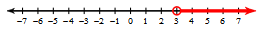 | Graph the inequality on a number line:  $$15>m$$
A child should no longer use a booster seat when they reach 4’9” tall. Janet is 59 inches tall.  Can she go without a booster seat? Explain? | Tim earns $120 plus $30 for each lawn he mows. Write an inequality to represent how many lawns he needs to mow to make more than $310.
Which has the best unit rate?  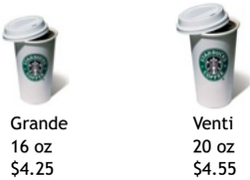 | Joe drove 538 miles in 9 hours 15 minutes. What was his average speed per hour?
Which equation(s) represents a proportional relationship?  A) y = 5 + x  B) y = 4x  C) y = 7x²  D) y = 2 - x | What does the point (1,90) represent on the graph?  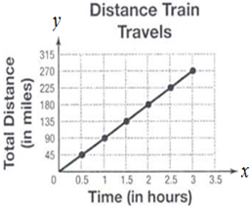
Maria works as a florist and worked 15 hours last week and earned $112.50. At that rate, how much will she earn if she works for 10 hours? | The proportion of red marbles to blue marbles in a jar is 2 to 5. If there are 35 blue marbles in the jar, how many red marbles are there?
John sells book bags. He sells a leather bag for $69.80, and the sales tax is 6% of the sale price. About how much is the sales tax on the book bag? | Cody has $700 in a savings account that pays 4% simple interest. How much will he have in 1 year?
Name: Weekly Math Review – Q2:6 Date:
Wednesday | Thursday
Karen has $\frac{1}{2 }$ cup of sugar. She is baking cookies and needs 1$\frac{1}{3 }$ cup for a recipe. How much more sugar does she need if she wants to triple the recipe? | Kit bought a soft drink and a sandwich for $9.00. What was the price of each if the sandwich cost 3.5 times as much as the soft drink?
Solve:  $$\frac{z}{8}+2≥3.25$$ | Solve:  $$9-5x>-81$$
Write an inequality that represents the graph below:  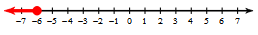 | Solve and graph the inequality on a number line:  $$-\frac{w}{2}≥-7$$
In a problem from Tuesday “Tim earns $120 plus $30 for each lawn he mows. Write an inequality to represent how many lawns he needs to mow to make more than $310”…graph the result on the number line below. | In the problem to the left, if Tim mows 9 lawns this week, by how much will he have exceeded his goal?
Max earned $66 in an 8 hour shift at work. How much does he make per hour? | Stephanie ran four laps around the school track in 7 minutes and 30 seconds. How many seconds per lap is that.
Which of these tables (if any) represent a proportional relationship?  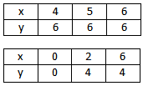 | What does the point (1,2) represent on the graph?  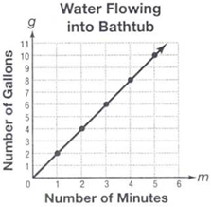
Write the equation for the table below?  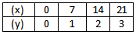 | Alex rides 45 miles in 3 hours. Write an equation that shows the relationship between the distance, d and the time, t that he rides if Alex rides at a constant rate of speed?
A salesman priced a four-wheeler at $3,500 the first day it was on the market. The 2nd day he reduced the price by 10%. What was the new price? | A wrestler competes in 25 matches. Of those matches, he wins 17. What percent of the matches did the wrestler win?

Name: Weekly Math Review – Q2:7 Date:
Monday | Tuesday
Solve:  $$-25+4h≤50.52$$ | Solve:  $$42<2m-10$$
Graph the inequality on a number line:  $$x≤4$$ | Write an inequality that represents the graph below:
Write an inequality for x that would give this rectangle an area of at least 117 ft².  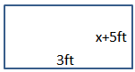 | In the problem to the left, solve the inequality and represent it on the number line below.
A 12 pack of soda is roughly $3.75. What is the cost per can of soda? | A regular #2 pencil can draw a line about 35 miles long or write roughly 45,000 words. How many words will fit in one mile?
Which equation(s) represents a proportional relationship?  A) y = 7x²  B) y = 2 + 3x  C) y = ½x  D) y = 5 - x | Circle the graph that represents a proportional relationship.  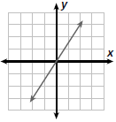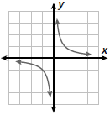
A store buys shirts for $12 each and marks up the price by 25%. What is the price for a shirt at this store? | Jim borrows $2,500 from his bank. The loan has a 5.4% annual simple interest rate. If it takes Jim two years to pay back the loan, what is the total amount he will be paying?
What is the slope between the points (–5,7) and (4,–8)? | What is the slope indicated in the table below?  X 0 1 2 3  Y 0 5 10 15
What is the slope below?  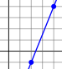 | Find the missing value so that the two points have a slope of $\frac{-17}{10}$.  (–3,9) and (x, –8)

Name: Weekly Math Review – Q2:7 Date:
Wednesday | Thursday
Solve:  $$8-6x>-18$$ | Solve:  $$12≥9(z+2)$$
Solve and graph the inequality on a number line:  $$42>g+27$$ | Write an inequality that represents the graph below:
A bowling alley offers unlimited bowling for $16.00 or charges 3.75 per game. How many games would you need to bowl for the unlimited bowling to be less expensive? | Tim earns $150/week plus $15.50 for each desk he assembles. Write an inequality to represent how many desks he needs assemble to make $400 in one week.
The rectangular wall below is painted in 15 minutes. How many square feet per minute were painted?  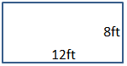 | In the diagram to the left, how long does it take to paint 1 square foot?
A car company can make 18 cars in 12 hours. How many cars can be made in 1 hour? | What is the cost of one gallon of gas?  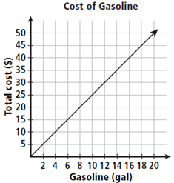
Julio invested $2,000 in a simple interest account for 3 years. She had earned $150 in interest by then end. What was the simple interest rate of the account? | Jon makes $78 in 12 hours of work for his mom. How much would Jon make in 20 hours or work?
What is the slope between the points (6,–3) and (–2,1)? | What is the slope indicated in the table below?  X 2 4 6 8  Y 10 20 30 40
What is the slope below?  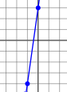 | Find the missing value so that the two points have a slope of $\frac{3}{2}$.  (0,y) and (2, –2)

Name: Weekly Math Review – Q2:9 Date:
Monday | Tuesday
Write an inequality to show how much more needs to be saved to reach $100  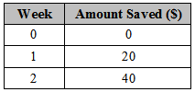 | Marisa wants to buy a DVD player that runs for at least $150. She already saved $80 and plans to save an additional $10 each week. Write an inequality that represents this.
In the problem above, how much money will be saved per year? | Simplify:  $$-\frac{2}{9}÷3\frac{1}{4}$$
At a currency exchange, 11 U.S. dollars can be exchanged for 10 Euros. How many Euros will you receive for 1 U.S. dollar? | As the same currency exchange as in the problem to the left, how many U.S. dollars will you receive for 1 Euro?
What percent of 132 is 40? | Maria and her sister each have a salad and a drink for lunch at a restaurant. A salad costs $4.75 and a drink costs $1.65. What was the total cost of the meal with a 15% tip?
What is the slope between the points (5,–7) and (–7,1)? | What is the slope indicated in the table below?  X 8 6 4 2  Y 2 4 6 8
These rectangles are similar, what is the scale factor?  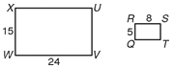 | The ratio of a model scale die cast motorcycle is  1 : 18. The model is  5.25 inches long. What is the length of the actual motorcycle in feet and inches?
Solve the proportional equation below:  $$\frac{2}{5}=\frac{8}{a}$$ | Solve the proportional equation below:  $$\frac{3}{r}=\frac{5}{r+3}$$
Solve the proportional equation below:  $$\frac{x+5}{5}=\frac{9}{8}$$ | Solve the proportional equation below:  $$\frac{3}{m-2}=\frac{7}{m+2}$$

Name: Weekly Math Review – Q2:9 Date:
Wednesday | Thursday
From an earlier problem on Tuesday “Marisa wants to buy a DVD player that runs for at least $150. She already saved $80 and plans to save an additional $10 each week.” Solve this inequality. | Which store has the lowest price after the discount?  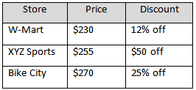
> , <, or =  $$-\frac{37}{8}______-4.63$$ | Simplify  $$3\left(\frac{1}{6}+\frac{2}{9}\right)+\left(-2\right)$$
Find the mean (average) of the data set below?  $$\frac{3}{4}, \frac{13}{5}, \frac{14}{10}, \frac{6}{24}$$ | Evaluate the expression.  ($\frac{4}{7}$ + 8)×(3 – (-4))
18 is what percent of 48? | The cost of a computer is $849. The store is offering a 20% discount and a sales tax of 6% is added after the discount. What is the total cost of the TV?
What is the slope below?  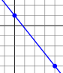 | Find the missing value so that the two points have a slope of $\frac{2}{7}$.  (–1, –1) and (x,1)
What is the slope below? | A gymnasium is 88 feet long and 76 feet wide. On a blueprint, the gymnasium is 5.5 inches long. What is the width of the gymnasium on the blueprint?
Solve the proportional equation below:  $$\frac{9}{r}=\frac{3}{10}$$ | Solve the proportional equation below:  $$\frac{1}{5}=\frac{x-9}{x}$$
Solve the proportional equation below:  $$\frac{9+x}{9}=\frac{7}{3}$$ | Solve the proportional equation below:  $$\frac{7}{5}=\frac{a+9}{a-5}$$

Name: Weekly Math Review – Q3:2 Date:
Monday | Tuesday
A TV production warehouse can assemble 120 TV’s in 4 hours. How long does it take to make one TV? | Complete the table to make this a proportional relationship.  x 0 2 8 14  y 0 3 12 ?
Luisa sells stuffed animals. She sells a stuffed elephant for $34.90, and the sales tax is 6% of the sale price. About how much is the sales tax on the elephant? | The Ace Motor Co. can assemble 14 cars in 35 minutes at its factory. How many cars can they assemble in 5 hours?
What is the slope between the points (8,–2) and (–7,10)? | What is the slope indicated in the table below?  X 5 10 15 20  Y 7 14 21 28
The ratio of a model car to a regular car is 1:16. The model is 6.25 inches long. What is the length of the actual car in feet and inches? | In the problem to the left, what if the ratio of the model car was 2:35, then what would be the actual length of the car?
Solve the proportional equation below:  $$\frac{7}{5}=\frac{a}{8}$$ | Solve the proportional equation below:  $$\frac{3}{8}=\frac{9}{b+10}$$
The lengths of two sides of a triangle are 4 and 6. Which measurement cannot be the length of the third side?  A) 6 B) 4  C) 3 D) 2 | In right triangle $∆ABC, m∠A=29°. Find m∠B$.  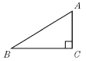
What is the shape of the cross section?  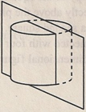 | Which of the following is a possible cross section of a rectangular prism?  A) Trapezoid  B) Triangle  C) Rectangle  D) Oval
What is the vertical cross section of the prism?
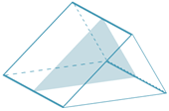

Name: Weekly Math Review – Q3:2 Date:
Wednesday | Thursday
Solve:  $$90≥-9(w+3)$$ | Explain/show why or why not the table below represents a proportional relationship.  x 3 5 8 9  y 17 27 42 47
Ashley bought 6 yds of ribbon for $5.28. What ratio is proportional to this?  A) $\frac{\$1.36}{2 yards}$ C) $\frac{\$2.64}{3 yards}$  B) $\frac{\$1.92}{3 yards}$ D) $\frac{\$3.25}{4 yards}$ | Mike is a car salesman. He earns $200 for every car he sells plus a 3% commission. If Mike sells 3 cars in one week for a total of $32,343, what are his total earnings for the week?
What is the slope below?  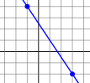 | Find the missing value so that the two points have a slope of –2.  (1,y) and (6,–5)
A circle has a radius of 3 feet. What is the circumference of a bigger circle if the scale factor of the smaller to bigger is 4:7? | In the problem to the left, what would be the ratio of the circumferences from the larger circle to the smaller circle?
Solve the proportional equation below:  $$\frac{b}{8}=\frac{b-8}{10}$$ | Solve the proportional equation below:  $$\frac{10}{3}=\frac{n-1}{n-4}$$
Draw an obtuse triangle that is also isosceles. | 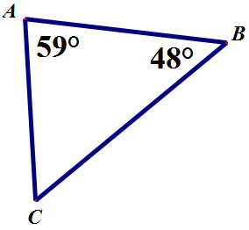  $Find m∠C$
The pyramid below was dissected by a horizontal plane. Which shape describes the pyramid’s horizontal cross section?  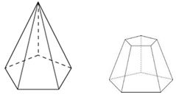 | What is the shape of a cross section that is parallel to the base of a cylinder?  A) rectangle  B) triangle  C) square  D) circle
What is the shape of a cross section that is perpendicular to the base of a cylinder?
A) rectangle
B) triangle
C) square
D) circle

Answer Key - Weekly Math Review – Q2:6
Monday |  | Tuesday | Wednesday |  |  | Thursday
Roxanna earns 1.5 her normal hourly rate for overtime pay. Last week, Roxanna earned $72.00 in overtime pay for 4 hours. What is Roxana’s normal hourly pay?  $12 per hour | Jan spent the day at the mall. She came home with $8.25. She spent $6.25 on earrings and 4 times that amount on a shirt. How much money did she take to the mall originally?  $39.50 |  |  | Karen has $\frac{1}{2 }$ cup of sugar. She is baking cookies and needs 1$\frac{1}{3 }$ cup for a recipe. How much more sugar does she need if she wants to triple the recipe? 3.5 cups | Kit bought a soft drink and a sandwich for $9.00. What was the price of each if the sandwich cost 3.5 times as much as the soft drink?  Drink: $2 Sandwich $7
Solve:  $$-5.37+q≤20.63$$  $$q≤26$$ | Solve:  $$7<m-5$$  $$m>12$$ |  |  | Solve:  $$\frac{z}{8}+2≥3.25$$  $$z≥10$$ | Solve:  $$9-5x>-81$$  $$x<18$$
Write an inequality that represents the graph below:  $$x>3$$ | Graph the inequality on a number line:  $$14≤m$$  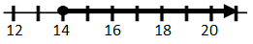 |  |  | Write an inequality that represents the graph below:  $$x≤-6$$ | Solve and graph the inequality on a number line:  $$-\frac{w}{2}≥-7$$  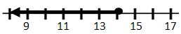
A child should no longer use a booster seat when they reach 4’9” tall. Janet is 59 inches tall.  Can she go without a booster seat? Explain?  Yes, 4’11’’ > 4’9’’ | Tim earns $120 plus $30 for each lawn he mows. Write an inequality to represent how many lawns he needs to mow to make more than $310.  120 + 30L > 310 |  |  | In the problem to the left, solve the inequality and graph the result on the number line below.  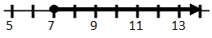 | In the problem to the left, if Tim mows 9 lawns this week, by how much will he have exceeded his goal?  $80
Which has the best unit rate? | Joe drove 538 miles in 9 hours 15 minutes. What was his average speed per hour?  58.16 mph |  |  | Max earned $66 in an 8 hour shift at work. How much does he make per hour?  $8.25 | Stephanie ran four laps around the school track in 7 minutes and 30 seconds. How many seconds per lap is that.  $$112.5$$
Which equation(s) represents a proportional relationship?  A) y = 5 + x  B) y = 4x  C) y = 7x²  D) y = 2 - x | What does the point (1,90) represent on the graph?  90 miles per hour |  |  | Which of these tables (if any) represent a proportional relationship? Neither | What does the point (1,2) represent on the graph?  2 gallons per minute
Maria works as a florist and worked 15 hours last week and earned $112.50. At that rate, how much will she earn if she works for 10 hours?  $75 | The proportion of red marbles to blue marbles in a jar is 2 to 5. If there are 35 blue marbles in the jar, how many red marbles are there? 14 |  |  | Write the equation for the table below?  $$y=\frac{1}{7}x$$ | Alex rides 45 miles in 3 hours. Write an equation that shows the relationship between the distance, d and the time, t that he rides if Alex rides at a constant rate of speed? d = 15t
John sells book bags. He sells a leather bag for $69.80, and the sales tax is 6% of the sale price. About how much is the sales tax on the book bag? $4.18 | Cody has $700 in a savings account that pays 4% simple interest. How much will he have in 1 year?  $728 |  |  | A salesman priced a four-wheeler at $3,500 the first day it was on the market. The 2nd day he reduced the price by 10%. What was the new price? $3150 | A wrestler competes in 25 matches. Of those matches, he wins 17. What percent of the matches did the wrestler win?  68%

Answer Key - Weekly Math Review – Q2:7
Monday | Tuesday | Wednesday | Thursday
Solve:  $$-25+4h≤50.52$$  $$h≤18.88$$ | Solve:  $$42<2m-10$$  $$m>26$$ | Solve:  $$8-6x>-18$$  $$x<\frac{13}{3}$$ | Solve:  $$12≥9(z+2)$$  $$z≤-\frac{2}{3}$$
Graph the inequality on a number line:  $x≤$4 | Write an inequality that represents the graph below:  $$x≤-1$$ | Solve and graph the inequality on a number line:  $$42≥g+27$$  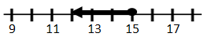 | Write an inequality that represents the graph below:  $$x≤0$$
Write an inequality for x that would give this rectangle an area of at least 117 ft².  $$3x+15≥117$$ | In the problem to the left, solve the inequality and represent it on the number line below.  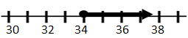 | A bowling alley offers unlimited bowling for $16.00 or charges 3.75 per game. How many games would you need to bowl for the unlimited bowling to be less expensive? $x>5$ | Tim earns $150/week plus $15.50 for each desk he assembles. Write an inequality to represent how many desks he needs assemble to make $400 in one week.  $$150 + 15.50x ≥400$$
A 12 pack of soda is roughly $3.75. What is the cost per can of soda?  $0.31 | A regular #2 pencil can draw a line about 35 miles long or write roughly 45,000 words. How many words will fit in one mile? About 1286 words | The rectangular wall below is painted in 15 minutes. How many square feet per minute were painted?  6.4 | In the diagram to the left, how long does it take to paint 1 square foot?  0.16 minutes or 9.375 seconds
Which equation(s) represents a proportional relationship?  A) y = 7x²  B) y = 2 + 3x  C) y = ½x  D) y = 5 - x | Circle the graph that represents a proportional relationship. | A car company can make 18 cars in 12 hours. How many cars can be made in 1 hour?  1.5 | What is the cost of one gallon of gas?  $2.50
A store buys shirts for $12 each and marks up the price by 25%. What is the price for a shirt at this store?  $15 | Jim borrows $2,500 from his bank. The loan has a 5.4% annual simple interest rate. If it takes Jim two years to pay back the loan, what is the total amount he will be paying?  $2,770 | Julio invested $2,000 in a simple interest account for 3 years. She had earned $150 in interest by then end. What was the simple interest rate of the account?  2.5% | Jon makes $78 in 12 hours of work for his mom. How much would Jon make in 20 hours or work?  $130
What is the slope between the points (–5,7) and (4,–8)  $$-\frac{5}{3}$$ | What is the slope indicated in the table below?  X 0 1 2 3  Y 0 5 10 15  5 | What is the slope between the points (6,–3) and (–2,1)  $$-\frac{1}{2}$$ | What is the slope indicated in the table below?  X 2 4 6 8  Y 10 20 30 40  5
What is the slope below? $$\frac{5}{2}$$ | Find the missing value so that the two points have a slope of $\frac{-17}{10}$.  (–3,9) and (x, –8)  x = 7 | What is the slope below?  7 | Find the missing value so that the two points have a slope of $\frac{3}{2}$.  (0,y) and (2, –2)  y = –5

Answer Key - Weekly Math Review – Q2:9
Monday | Tuesday | Wednesday | Thursday
Write an inequality to show how much money is needed to reach $100 $x≥\$60$ | Marisa wants to buy a DVD player that runs for at least $150. She already saved $80 and plans to save an additional $10 each week. Write an inequality that represents this. $80+10x≥150$ | Solve the inequality that you wrote for the problem to the left.  $$x≥7$$ | Which store has the lowest price after the discount?
In the problem above, how much money will be saved per year?  $1040 | Simplify:  $$-\frac{2}{9}÷3\frac{1}{4}$$  $$-\frac{8}{117}$$ | > , <, or =  $$-\frac{37}{8}______-4.63$$  > | Simplify  $$3\left(\frac{1}{6}+\frac{2}{9}\right)+\left(-2\right)$$  $$-\frac{5}{6}$$
At a currency exchange, 11 U.S. dollars can be exchanged for 10 Euros. How many Euros will you receive for 1 U.S. dollar?  0.91 | As the same currency exchange as in the problem to the left, how many U.S. dollars will you receive for 1 Euro?  1.1 | Find the mean (average) of the data set below?  $$\frac{3}{4}, \frac{13}{5}, \frac{14}{10}, \frac{6}{24}$$  1.25 | Evaluate the expression.  ($\frac{4}{7}$ + 8)×(3 – (-4))  60
What percent of 132 is 40?  $$30.\overline{30}$$ | Maria and her sister each have a salad and a drink for lunch at a restaurant. A salad costs $4.75 and a drink costs $1.65. What was the total cost of the meal with a 15% tip?  $14.72 | 18 is what percent of 48?  37.5% | The cost of a computer is $849. The store is offering a 20% discount and a sales tax of 6% is added after the discount. What is the total cost of the TV?  $719.95
What is the slope between the points (5,–7) and (–7,1)?  $$-\frac{2}{3}$$ | What is the slope indicated in the table below?  X 8 6 4 2  Y 2 4 6 8  –1 | What is the slope below?  $$\frac{4}{5}$$ | Find the missing value so that the two points have a slope of $\frac{2}{7}$.  (–1, –1) and (x,1)  x = 6
These rectangles are similar, what is the scale factor?  $$\frac{1}{3}$$ | The ratio of a model scale die cast motorcycle is  1 : 18. The model is  5.25 inches long. What is the length of the actual motorcycle in feet and inches?  7ft 10.5in | What is the slope below?  $$-\frac{5}{4}$$ | A gymnasium is 88 feet long and 76 feet wide. On a blueprint, the gymnasium is 5.5 inches long. What is the width of the gymnasium on the blueprint?  4.75 inches
Solve the proportional equation below:  $$\frac{2}{5}=\frac{8}{a}$$  a = 20 | Solve the proportional equation below:  $$\frac{3}{r}=\frac{5}{r+3}$$  r = 4.5 | Solve the proportional equation below:  $$\frac{9}{r}=\frac{3}{10}$$  r = 30 | Solve the proportional equation below:  $$\frac{1}{5}=\frac{x-9}{x}$$  a = 11.25
Solve the proportional equation below:  $$\frac{x+5}{5}=\frac{9}{8}$$  $$x= \frac{5}{8}$$ | Solve the proportional equation below:  $$\frac{3}{m-2}=\frac{7}{m+2}$$  x = 5 | Solve the proportional equation below:  $$\frac{9+x}{9}=\frac{7}{3}$$  x = 12 | Solve the proportional equation below:  $$\frac{7}{5}=\frac{a+9}{a-5}$$  a = 40

Answer Key - Weekly Math Review – Q3:2
Monday | Tuesday | Wednesday | Thursday
A TV production warehouse can assemble 120 TV’s in 4 hours. How long does it take to make one TV?  2 minutes | Complete the table to make this a proportional relationship. 21  x 0 2 8 14  y 0 3 12 ? | Solve:  $$90≥-9(w+3)$$  $$w ≥-13$$ | Explain/show why or why not the table below represents a proportional relationship. Explanations will vary  x 3 5 8 9  y 17 27 42 47
Luisa sells stuffed animals. She sells a stuffed elephant for $34.90, and the sales tax is 6% of the sale price. About how much is the sales tax on the elephant?  $2.09 | The Ace Motor Co. can assemble 14 cars in 35 minutes at its factory. How many cars can they assemble in 5 hours?  120 cars | Ashley bought 6 yds of ribbon for $5.28. What ratio is proportional to this?  A) $\frac{\$1.36}{2 yards}$ C) $\frac{\$2.64}{3 yards}$  B) $\frac{\$1.92}{3 yards}$ D) $\frac{\$3.25}{4 yards}$ | Mike is a car salesman. He earns $200 for every car he sells plus a 3% commission. If Mike sells 3 cars in one week for a total of $32,343, what are his total earnings for the week? $1570.29
What is the slope between the points (8,–2) and (–7,10)  $$-\frac{4}{5}$$ | What is the slope indicated in the table below?  X 5 10 15 20  Y 7 14 21 28  $$\frac{7}{5}$$ | What is the slope below?  $$-\frac{3}{2}$$ | Find the missing value so that the two points have a slope of –2.  (1,y) and (6,–5)  y = 5
The ratio of a model car to a regular car is 1:16. The model is 6.25 inches long. What is the length of the actual car in feet and inches? 8’ 4’’ | In the problem to the left, what if the ratio of the model car was 2:35, then what would be the actual length of the car?  9ft 1.375in | A circle has a radius of 3 feet. What is the circumference of a bigger circle if the scale factor of the smaller to bigger is 4:7?  10.5$π$ or 32.98 | In the problem to the left, what would be the ratio of the circumferences from the larger circle to the smaller circle?  $$\frac{7}{4}$$
Solve the proportional equation below:  $$\frac{7}{5}=\frac{a}{8}$$  a = 11.2 | Solve the proportional equation below:  $$\frac{3}{8}=\frac{9}{b+10}$$  b = 14 | Solve the proportional equation below:  $$\frac{b}{8}=\frac{b-8}{10}$$  b = –32 | Solve the proportional equation below:  $$\frac{10}{3}=\frac{n-1}{n-4}$$  $$n=-\frac{37}{7}$$
The lengths of two sides of a triangle are 4 and 6. Which measurement cannot be the length of the third side?  A) 6 B) 4  C) 3 D) 2 | In right triangle $∆ABC, m∠A=29°. Find m∠B$.  61º | Draw an obtuse triangle that is also isosceles. | $Find m∠C$ 73º
What is the shape of the cross section? rectangle | Which of the following is a possible cross section of a rectangular prism?  A) Trapezoid  B) Triangle  C) Rectangle  D) Oval | The pyramid below was dissected by a horizontal plane. Which shape describes the pyramid’s horizontal cross section?  pentagon | What is the shape of a cross section that is parallel to the base of a cylinder?  A) rectangle  B) triangle  C) square  D) circle
What is the vertical cross section of the prism? triangle |  |  | What is the shape of a cross section that is perpendicular to the base of a cylinder?  A) rectangle  B) triangle  C) square  D) circle

