6TH GRADE YOGA INDEPENDENT STUDY PROJECT
PART 2

NAME:

COHORT:

Rubric attached at the back!
Got questions? Need support? Ms. Fleming will be available from 1:10-2:10pm Monday – Friday via text, email, and phone!

Contact Ms. Fleming:
443-386-9389; efleming@thecrossroadsschool.org

Part I. Matching

Match the category of pose on the left to the way that they help us on the right:

- back bends release stress
- forward folds give us energy
- twists give us confidence
- standing poses calm us down
Part II. Poses and Categories
Place the poses on the following pages (attached to the back of this section) into the correct categories by writing down the name of the pose in the correct box.

CATEGORY 1: BACKBENDS

CATEGORY 2: FORWARD FOLDS

CATEGORY 3: TWISTS

CATEGORY 4: STANDING POSES

Part III. Scenarios
Below, you will find a number of different scenarios. You must pick at least TWO poses for the person to practice in each scenario, and explain why you chose those poses. Use your pose list to help you!

Scenario 1:
It’s 9pm, and Peter just got home from a long day of school and basketball practice. He has a test in math tomorrow, and wants to do well. Peter is feeling tired, and stressed out.

Given what you know about how Peter is feeling, what is one yoga pose that Peter could use in this situation? Why should he use this pose?

What is a second yoga pose that Peter could use in this situation? Why should he use this pose?

Scenario 2:
It’s Jada’s birthday and she is so excited about having her friends over for her party after school, that she can’t sit still or stay focused in class.

Given what you know about how Jada is feeling, what is one yoga pose that Jada could use in this situation? Why should she use this pose?

What is a second yoga pose that Jada could use in this situation? Why should she use this pose?

Scenario 3:
Brayan stayed up late last night watching his favorite sports team play. He had to wake up at 6am to get ready for school. When he arrives at school, his new phone falls out of his backpack and the screen shatters on the floor. Brayan wasn’t paying attention because he was tired, and now that his phone is broken, he is angry.

Given what you know about how Brayan is feeling, what is one yoga pose that he could use in this situation? Why should he use this pose?

What is a second yoga pose that Brayan could use in this situation? Why should he use this pose?

Part IV. Pose Research
Pick ONE pose of your choice from each category to research. You should be able to answer the following questions from your research. Each category should take you about a day to complete.

Websites to use:
- yogajournal.com/pose
- yogabasics.com/asana
You can also type the name of the pose into Google and look at some websites that come up. Do NOT use Wikipedia! Make sure you write down the name of the website you used to research each pose in the box at the bottom of the page.

VOCABULARY:
Contraindications = when you SHOULDN’T practice the pose.
Sanskrit name = name of the pose in the original Indian language
Benefits = how the pose helps you

Backbends:
1. What BACKBEND did you choose?

2. What is the Sanskrit name of this pose?

3. What are the benefits of this pose?

4. What parts of the body does this help?

5. Give an example of a time you might use this pose.

6. When should you NOT use this pose?

7. Any other information you discovered?

Website Used:
Forward Folds:
1. What FORWARD FOLD did you choose?

2. What is the Sanskrit name of this pose?

3. What are the benefits of this pose?

4. What parts of the body does this help?

5. Give an example of a time you might use this pose.

6. When should you NOT use this pose?

7. Any other information you discovered?

Website Used:
Twists:
1. What TWIST did you choose?

2. What is the Sanskrit name of this pose?

3. What are the benefits of this pose?

4. What parts of the body does this help?

5. Give an example of a time you might use this pose.

6. When should you NOT use this pose?

7. Any other information you discovered?

Website Used:
STANDING POSES
1. What TWIST did you choose?

2. What is the Sanskrit name of this pose?

3. What are the benefits of this pose?

4. What parts of the body does this help?

5. Give an example of a time you might use this pose.

6. When should you NOT use this pose?

7. Any other information you discovered?
Website Used:

In addition, research the following pose:
Fearless Heart Pose
1. What is the Sanskrit name of this pose?

2. What are the benefits of this pose?

3. What parts of the body does this help?

4. Give an example of a time you might use this pose.

5. When should you NOT use this pose?

6. Any other information you discovered?
Website Used:

Poses: Use these poses to help you answer Part II! You must place each of these poses in the appropriate category!
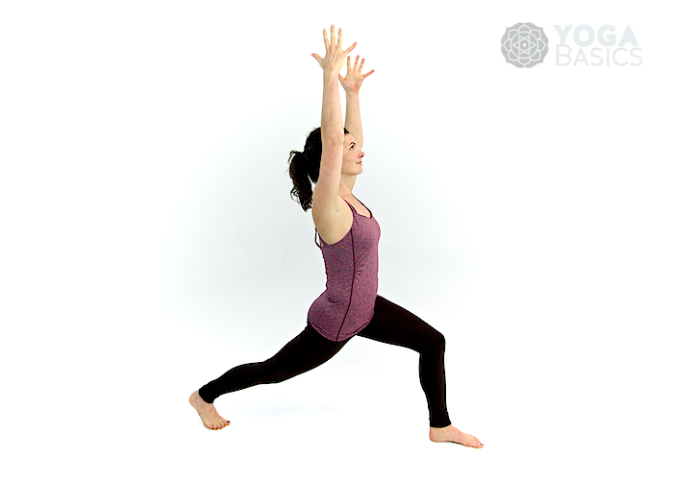

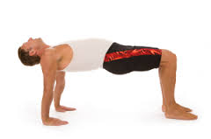
EAGLE POSE HIGH LUNGE

TABLE TOP BOAT POSE

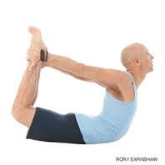

CAMEL BOW
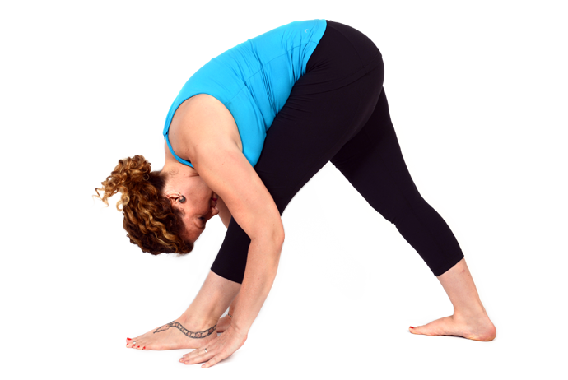
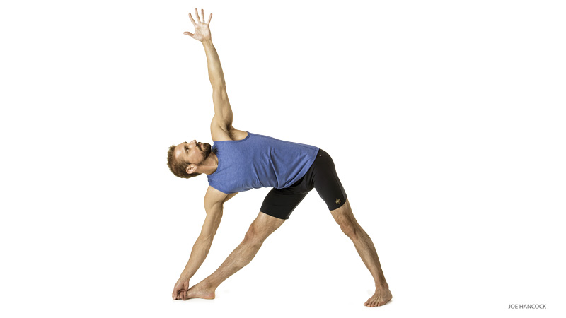

Triangle Pose Pyramid Pose

Crescent Moon Figure 4 Pose

Runner’s Stretch Side Plank

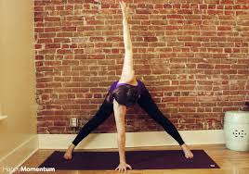

Wide Legged Forward Fold Twisting Wide Legged Forward Fold

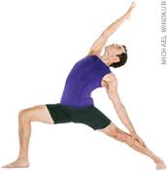

Reverse Warrior Earth Pose
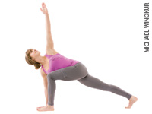
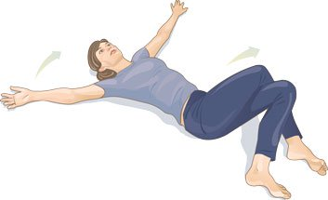

Twisting Lunge Reclined Eagle

Dancer’s Pose
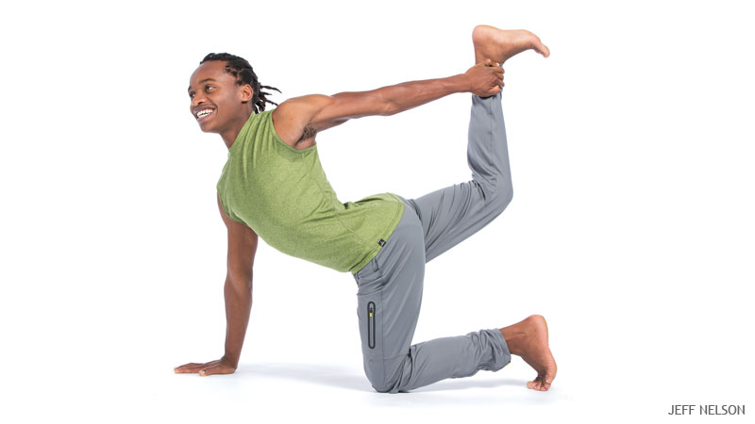
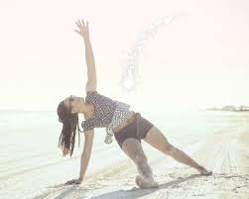

Table Thigh Stretch Fallen Star Pose
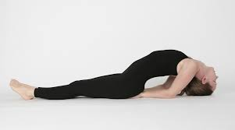

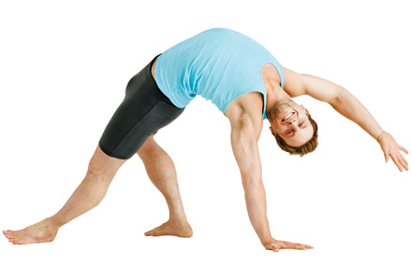

Wild Thing Pose Fish Pose

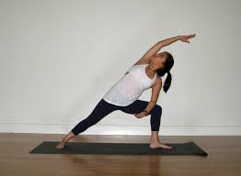
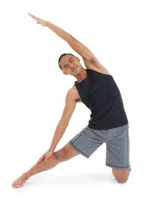

Gate Pose Side Angle Pose

Name: __________________________________________

Date: ____________________________________________

Independent Study Project—Section 2

 | Exceeding | Proficient | Approaching | Developing
Target Area: Yoga | 4 | 3 | 2 | 1
Anchor Standard:  6.Y.1. Students will identify the name, benefits, and category of specific poses and identify situations in which they’ll use them at school and at home, given scenarios.  Task or Assignment:  Independent Study Project | How the standard is demonstrated:  Student demonstrates exceeding understanding of all criteria in the standard by accurately completing all tasks in parts 1-3 AND accurately completes the research process for ALL poses in part 4.  (Parts 1, 2, 3, 4, correct) | How the standard is demonstrated:  Student demonstrates proficient understanding of all criteria in the standard by accurately completing all tasks in parts 1-3 AND accurately completes the research process for at least TWO poses in part 4.  (Parts 1, 2, 3 and part of 4 correct) | How the standard is demonstrated:  Student demonstrates developing understanding of all criteria in the standard by accurately completing all tasks in parts 1-3.  (Parts 1, 2, and 3 correct) | How the standard is demonstrated:  Student demonstrates developing understanding of all criteria in the standard by accurately completing only 2 out of the first three parts of the assignment.  (2 out of 3 parts correct)

Questions? Need help?

Email Ms. Fleming at efleming@thecrossroadsschool.org or call / text at 443-386-9389.

Parts 1-3 and at least 2 sections of part 4 are required to be completed in their entirety in order to earn a 3.

Assignment can be turned in via email or hard copy.

